|  |  |  |
| --- | --- | --- |
| Exp No. 1 | **INSTALLATION OF GIT AND CREATING REPOSITORIES.** | Regno: URK24CS1062 |
| Date: |

**Aim:**

To demonstrate Git , Github and its repositories , covering setup , managing visibility and executing basic git commands and operations.

Description:

Git is a free , open-source version control system that helps programmers and developers manage source code and collaborate on projects.

**Installing Git:**

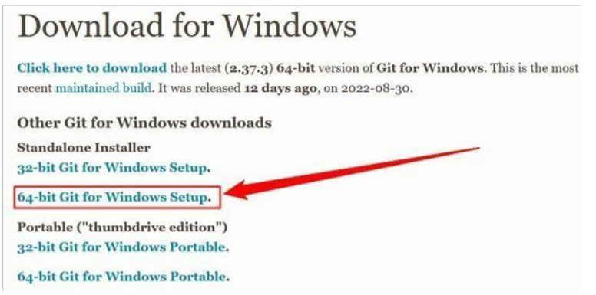The easiest way to install git is to download the executable file for your operating system from Git’s own website. Click on the downloaded ‘exe’ file and install git on your system.

**Managing Private and Public Git Repositories:**

* Github will detach public forks of the repository and put them in a new network.
* Any published github pages will be unpublished.
* Github will not include the repository in the Github Archieve Program.
* Github advanced security features , such as code scanning will stop working.

**Making a repository public:**

* Github will detach private forks and turn them into a standalone private repository.
* Once the repository’s public , community profile can be viewed to see whether the project meets best practices for supporting contributors.
* The repository will automatically gain access to github advanced security features.

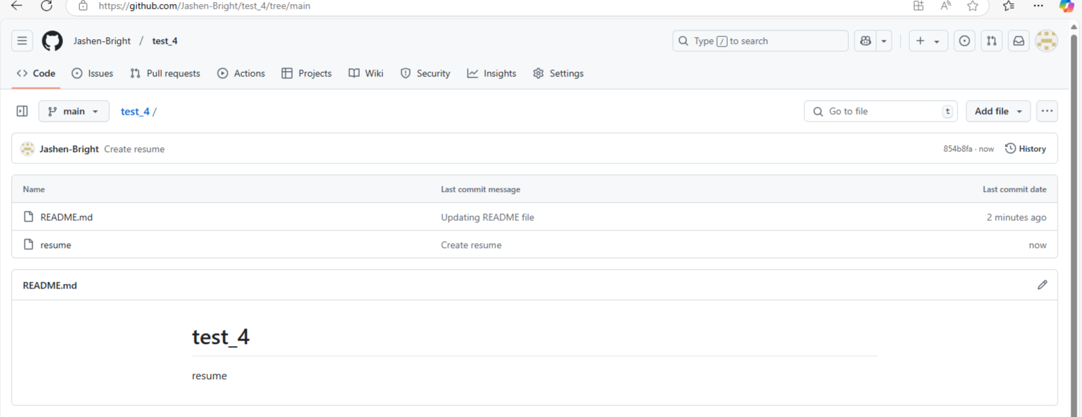

**Changing a repository’s visibility:**

1. On github , navigate to the main page of the repository.
2. Click on settings (from the dropdown menu).
3. In the ‘Danger Zone’ section , to the right of ‘Change Repository Visibility’ , click ‘change visibility’ .
4. Select a visibility.
5. To verify , write the name of repository you want to change the visibility of.
6. Click , ‘I understand, change repository visibility’.

**Conclusion :** Hence experiment 1 has been successfully completed.